Newspaper announcement….

Christ Presbyterian Church
Cordially invites you, family & friends to their
Easter Services
- Good Friday Service – April 14 at 7:00 pm
Special Music: (Joe to insert)
- Easter Services – Sunday, April 16th at 9:15 am & 11:15 am

We are conveniently located
135 Whitney Avenue – New Haven
(1 block North of Trumbull St., off I-91, exit 3
777-6960 or visit our website at christpresnewhaven.org

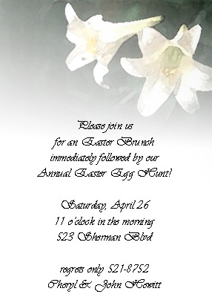

Christ Presbyterian Church

Cordially invites you,
family & friends to their

Easter Services

Good Friday Service
April 14 at 7:00 pm
Special Music:

(Joe to insert)

Easter Services
Sunday, April 16th at 9:15 am & 11:15 am

We are conveniently located
135 Whitney Avenue – New Haven
(1 block North of Trumbull St., off I-91, exit 3)
777-6960 or visit our website at christpresnewhaven.org

